Applications of Rice theorem

Formal language theory:
Indicators of undecidability for several classes of languages, including context-free languages, regular languages, and others, can be demonstrated using Rice’s theorem.

Compiler design:
Rice’s theorem is used in the design of compilers and programming languages. For example, it can be used to prove that certain optimizations are sound, or that certain transformations preserve the meaning of a program.

Program verification:
Rice’s theorem can be used in program verification to show that certain properties of a program cannot be automatically verified. This is important because it can help identify areas where manual verification or testing is necessary.

Artificial intelligence:
Rice’s theorem has been applied to the study of artificial intelligence, particularly in the field of machine learning. For example, it has been used to prove that certain learning problems are inherently difficult to solve using a machine learning algorithm.

Software Testing:
In software testing and debugging, a common goal is to identify whether a particular program, or a block of code, can potentially lead to a software crash. This forms a non-trivial property, which, in the light of Rice’s theorem, becomes undecidable. Thus, no software testing method can guarantee finding every bug.

Database Query Optimisation:
In database management systems, there's often a need to determine equivalent queries to optimise performance. A DBMS should be able to decide if two database queries are equivalent, i.e., if they will always return the same output for all databases. However, this forms a non-trivial semantic property making it undecidable under Rice’s theorem. So, no algorithm can perfectly decide query equivalence.

Halting Problem
The Halting Problem is a classic computer science problem that falls directly under the umbrella of Rice's theorem. In its simplest form, it is a question: "Given an arbitrary computer program and an input, will the program eventually halt when run with that input, or will it continue to run forever?" As straightforward as this question might seem, Alan Turing proved that it's impossible to create an algorithm that can answer this question correctly for all possible program-input pairs.

Church Turing Hypothesis
Alan Turing gave the idea for logical computing machines that worked on Turing expressions.
A mechanical method was made for this. Assume this method is MM, and we use it to manipulate strings by logic and mathematics.
Requirements for the Church-Turing thesis
This defined method MM should pass the following:
- It shouldn't require any complex processing requirements.
- We obtain output after performing a finite number of steps.
- We can implement the method MM in the real world.
- The number of instructions for MM should be finite.
We describe this thesis under two main categories:
- Church-Turing thesis for decidability problems: A decidability problem can be solved effectively if there exists a Turing machine that halts for all of its input strings and calculates the solution.
- Extended Church-Turing thesis for decidability problems: A decidability problem is partially solvable if there exists a Turing machine that accepts the elements of the problem whose answer is "yes."
Proof for recursive functions
We can compute recursive functions by considering the following assumptions:
- All functions must be computable.
- Assume a computable function ff. After performing elementary operations, the function will transform into a new function gg. gg is automatically a computable function.
Applications of the thesis
This thesis finds its applications in many calculable and computational fields. Some of these are:
- Lambda calculus
- Single and multiple tape Turing machines
- Counter machine model
- Register machine, a machine similar to the computer
- Markov algorithms
- Combinatory logic
- Pointer machines
A quick glance at some practical applications of the Church Turing Thesis can help illuminate its importance:
- Design of Digital Computers: Digital computers function based on the principles laid down by the Church Turing Thesis. If there exists an algorithm to solve a problem, a computer can be programmed to implement that algorithm.
- Creation of Programming Languages: The design principles of almost all high-level programming languages are also rooted in this thesis. They all allow for the expression of a general-purpose set of instructions — algorithms in other words — that a computer can execute.
- Fundamentals of Artificial Intelligence: When exploring artificial intelligence and machine learning, the Church Turing Thesis is often invoked. For instance, if a human intelligence process can be encapsulated as an algorithm, this thesis suggests a machine can be programmed to replicate that process.

Application of different automata:
- Finite Automata ' A finite automaton is a mathematical model consisting of states, input symbols, and a transition function. It reads input symbols and transitions between states based on the transition function, either accepting or rejecting the input. It's used to model and analyze systems with a finite number of states in various fields. Some applications of finite automata are as follows:
  - Recognizing patterns in text or other data: Finite automata can be used to search for and recognize specific patterns in text or other data. For example, a finite automaton can be used to recognize email addresses, URLs, or phone numbers in text. This is commonly used in text processing software, such as search engines or spam filters.
  - Implementing regular expressions in programming languages: Regular expressions are a way to describe patterns in text using a set of rules. These rules can be translated into a finite automaton, which is used to match the pattern in the input text. Many programming languages, such as Perl, Python, and Java, use finite automata to implement regular expressions.
  - Validating input in form fields on websites: Finite automata can be used to validate user input in form fields on websites. For example, a finite automaton can be used to ensure that a user enters a valid email address or password that meets certain criteria, such as length or character requirements.
  - Modeling digital circuits and switching systems: Finite automata can be used to model digital circuits and switching systems, such as those found in computers and other electronic devices. This can help engineers design and optimize these systems for maximum efficiency and performance.
  - Designing and analyzing computer algorithms and programs: Finite automata can be used to design and analyze computer algorithms and programs. They can help programmers understand the behavior of the program and identify potential errors or inefficiencies.
  - Building compilers and interpreters: Finite automata are used in the development of compilers and interpreters, which are programs that translate high-level programming languages into machine code that can be executed by a computer. Finite automata are used to recognize and process the syntax and semantics of the programming language.
  - Analyzing the behavior of software and hardware systems: Finite automata can be used to analyze the behavior of software and hardware systems, such as operating systems or network protocols. They can help identify bugs or vulnerabilities in the system and optimize its performance.
  - Verifying the correctness of software and hardware systems: Finite automata can be used to verify the correctness of software and hardware systems by checking whether they satisfy certain requirements or specifications.
  - Developing language models and machine learning algorithms: Finite automata are used in the development of language models and machine learning algorithms, which are used in natural language processing and other applications. They can help identify patterns in data and make predictions based on those patterns.
  - Studying formal languages and their properties: Finite automata are used in the study of formal languages and their properties. They can help identify the structure and rules of different types of languages and the limitations of those languages in terms of expressiveness and complexity.
- Push Down Automata - A pushdown automaton (PDA) is a mathematical model similar to a finite automaton, but with a stack for memory. It has states, input symbols, a transition function that maps states, input symbols, and top stack symbols to other states and stack operations, and a set of accepting states. The PDA reads input symbols and manipulates the stack, either accepting or rejecting the input. PDAs are used to model more complex systems in computer science and linguistics. Some applications of push down automata are as follows:
  - Parsing context-free grammars: Pushdown automata are often used to parse context-free grammars. Context-free grammars are a type of formal grammar that is commonly used to describe the structure of programming languages, markup languages, and other languages. Pushdown automata can recognize whether a string of symbols in a language can be generated by a given context-free grammar.
  - Implementing stack-based memory management: Pushdown automata can be used to implement stack-based memory management in programming languages. In this type of memory management, memory is allocated and deallocated from a stack data structure. Pushdown automata can be used to implement the stack and manage the allocation and deallocation of memory.
  - Modeling natural language processing: Pushdown automata can be used to model natural language processing (NLP) systems. NLP is a subfield of artificial intelligence that focuses on the interaction between computers and human languages. Pushdown automata can be used to recognize and parse sentences in natural language, which can be used to build more advanced NLP systems.
  - Recognizing context-sensitive languages: Pushdown automata can be used to recognize context-sensitive languages, which are a type of formal language that is more complex than context-free languages. Context-sensitive languages are used in many applications, such as natural language processing and database management.
  - Modeling network protocols: Pushdown automata can be used to model network protocols, such as the Transmission Control Protocol (TCP) and the User Datagram Protocol (UDP). These protocols are used to facilitate communication between computers over a network. Pushdown automata can be used to recognize and process the messages exchanged between computers.
- Overall, pushdown automata are useful in a wide range of applications where more complex language or memory management is required, such as programming languages, natural language processing, network protocols, and database management. They provide a more powerful computational model than finite automata, allowing for more complex computations and recognition of more complex languages.
- Linear Bounded Automata - Linear bounded automata (LBAs) are a type of Turing machine that has a limited amount of memory, but the amount of memory is proportional to the size of the input. Here are some applications of LBAs:
  - Model checking: LBAs can be used in model checking, which is a method for verifying the correctness of a software or hardware system. In model checking, the behavior of the system is modeled as a finite state machine, and then checked against a set of properties using an LBA.
  - String matching: LBAs can be used in string matching applications, such as searching for a pattern in a DNA sequence. LBAs can process and analyze large amounts of data, and can be used to recognize patterns and identify matches.
  - Natural language processing: LBAs can be used in natural language processing applications, such as parsing sentences and translating between languages. LBAs can be used to analyze and process complex sentences and generate translations.
  - Image and speech recognition: LBAs can be used in image and speech recognition applications, such as recognizing objects in images and transcribing speech. LBAs can process and analyze large amounts of data and identify patterns, which can be used to recognize and classify images and speech.
  - Genome assembly: LBAs can be used in genome assembly applications, where the goal is to reconstruct the complete DNA sequence of an organism. LBAs can process and analyze large amounts of data and identify overlaps and patterns, which can be used to assemble the genome.
- Overall, LBAs are useful in a wide range of applications where more powerful computational models are required, such as model checking, natural language processing, image and speech recognition, and genome assembly. LBAs provide a more powerful computational model than finite automata and pushdown automata, allowing for more complex computations and recognition of more complex languages.
- Turing Machine - A Turing machine is a mathematical model of a general-purpose computer that can perform any computation that any other computer can. Here are some applications of Turing machines:
  - Artificial intelligence: Turing machines can be used in artificial intelligence applications, such as natural language processing and machine learning. Turing machines can be used to process and analyze large amounts of data, recognize patterns, and learn from examples.
  - Cryptography: Turing machines can be used in cryptography, which is the study of techniques for secure communication. Turing machines can be used to encrypt and decrypt messages, and to generate random numbers.
  - Algorithmic complexity theory: Turing machines are used in algorithmic complexity theory, which is the study of the computational resources required to solve problems. Turing machines can be used to analyze the time and space complexity of algorithms, and to determine whether a problem is solvable by a computer.
  - Compiler design: Turing machines can be used in compiler design, which is the process of transforming source code into executable code. Turing machines can be used to implement the parsing and translation phases of the compiler, which involves recognizing the syntax of the source code and generating the corresponding executable code.
  - Computation theory: Turing machines are used in computation theory, which is the study of the nature and limits of computation. Turing machines can be used to define the class of computable functions, which are functions that can be computed by a Turing machine.
- Overall, Turing machines are a fundamental tool in computer science and are used in a wide range of applications, including artificial intelligence, cryptography, algorithmic complexity theory, compiler design, and computation theory. They provide a powerful computational model that can simulate any other computer, allowing for the analysis and design of complex systems.

Expressive powers of different automata:
The expressive power of different automata refers to the class of languages that can be recognized or generated by each type of automaton. Here is an overview of the expressive power of different automata:
- Finite automata: Finite automata can recognize regular languages, which are languages that can be defined by a regular expression or a finite state machine.
- Pushdown automata: Pushdown automata can recognize context-free languages, which are languages that can be defined by a context-free grammar.
- Linear bounded automata: Linear bounded automata can recognize context-sensitive languages, which are languages that can be defined by a context-sensitive grammar.
- Turing machines: Turing machines can recognize recursively enumerable languages, which are languages that can be defined by a recursive function.
It is worth noting that the class of recursively enumerable languages includes all the other language classes mentioned above. This means that any language that can be recognized by a finite automaton, pushdown automaton, or linear bounded automaton can also be recognized by a Turing machine, but not the other way around.

https://medium.com/@tejas.dharmik20/automata-theory-limitations-and-its-applications-91f1f5be5940

https://www.geeksforgeeks.org/basic-theorems-in-toc-myhill-nerode-theorem/

Differentiate between Regular Language And Context Free Languages ?
Regular Language And Context-Free Language are two important concepts in formal language theory. Both are classes of formal languages that are used to describe sets of strings that can be generated by a set of rules or symbols.
Click here to Download the Answer.
Briefly Explain Regular Languages And Context-Free Languages.
A Regular Language is a language that can be generated by a regular expression or a finite-state machine. These languages are characterized by their simple grammatical rules, which can be expressed using only basic operations such as concatenation, alternation, and Kleene closure. Regular languages are commonly used in computer science, especially in lexical analysis and pattern matching.
On the other hand, a context-free language is a language that can be generated by context-free grammar. These languages are characterized by their more complex grammatical rules, which allow for the creation of nested structures and the use of recursion. Context-free languages are used in many areas of computer science, including parsing, compilers, and natural language processing.
Key differences between Regular Languages And Context-Free Languages are:-
One of the key differences between Regular Languages And Context-Free Languages is the type of automaton used to recognize them. Regular languages can be recognized by finite-state machines, while context-free languages require a more powerful computational model, such as a pushdown automaton.
Another difference is the level of expressiveness. Context-free languages are more expressive than regular languages, as they allow for the creation of more complex structures and more flexible grammatical rules. Regular languages are more limited in terms of their expressiveness, as they can only generate a limited set of simple structures.
In terms of their practical applications, regular languages are commonly used in programming languages and data processing applications, where they are used to specify patterns and extract information from text data. Context-free languages, on the other hand, are commonly used in natural language processing, where they are used to parse and analyze the structure of sentences and other forms of human language.
Regular Languages And Context-Free Languages: Conclusion
In conclusion, Regular Languages And Context-Free Languages are two important classes of formal languages that are used to describe sets of strings or sequences. While both have their own unique properties and applications, context-free languages are generally more expressive and powerful than regular languages and are used in a wider range of applications in computer science and natural language processing.
https://www.geeksforgeeks.org/difference-between-context-free-grammar-and-regular-grammar/

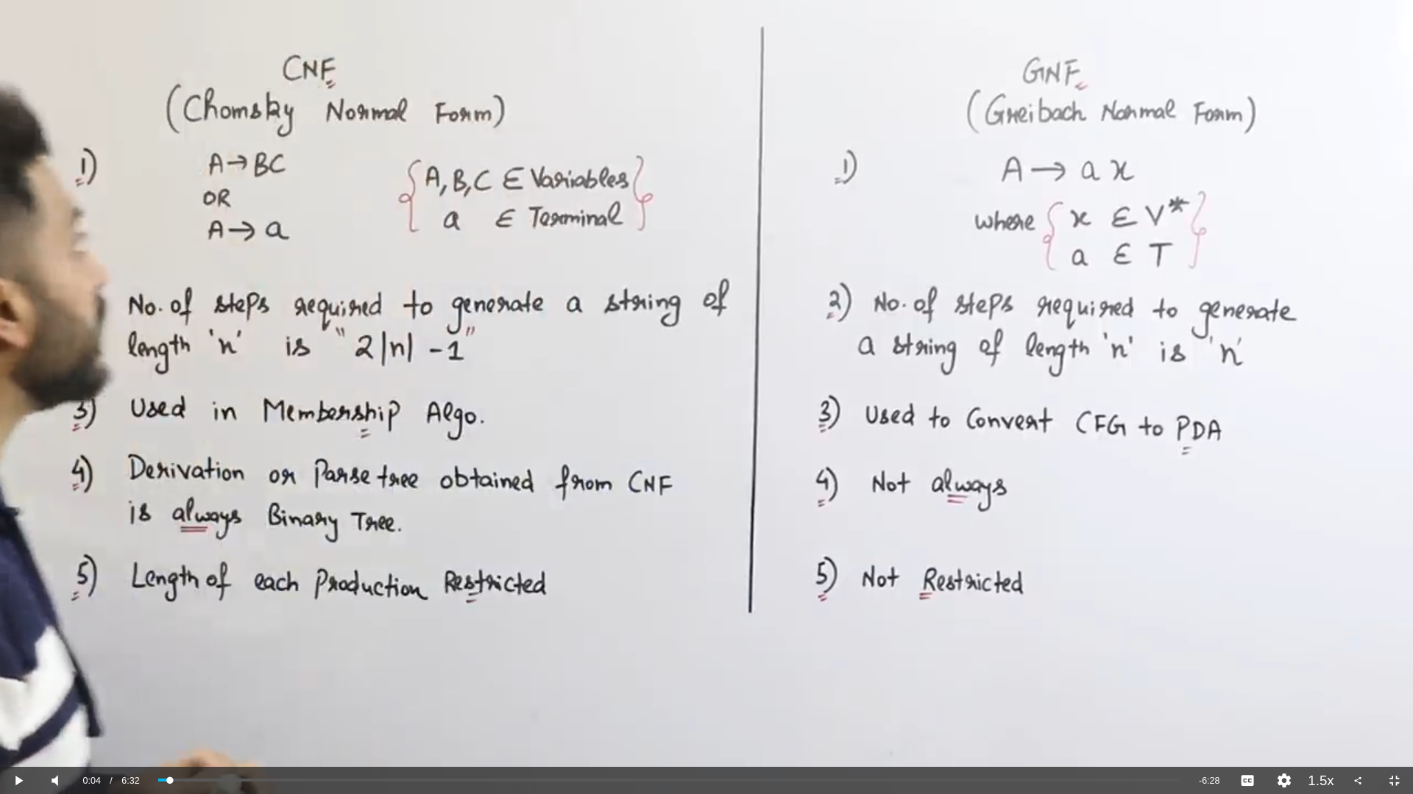

cfl vs rl

pda relation with cfg

